**Taller de Locators ESPN**

**Estudiante:** Jinson Stevenson Moreno Aguilar

**Desarrollo:**

* **Login Test:**

**Main Page**

//a[@id='global-user-trigger']

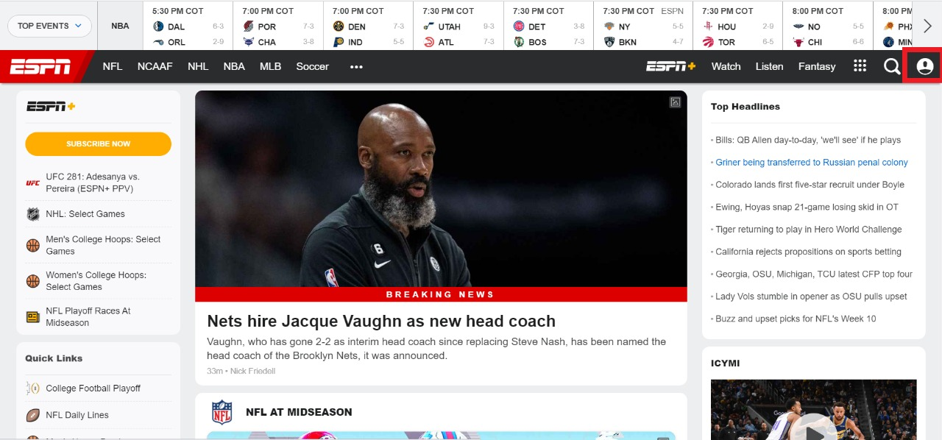

**Main Page (User Page)**

a[tref="/members/v3_1/login"]

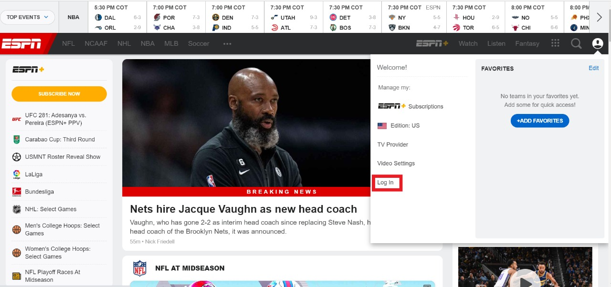

**Main Page (Login Page – Modal Window)**

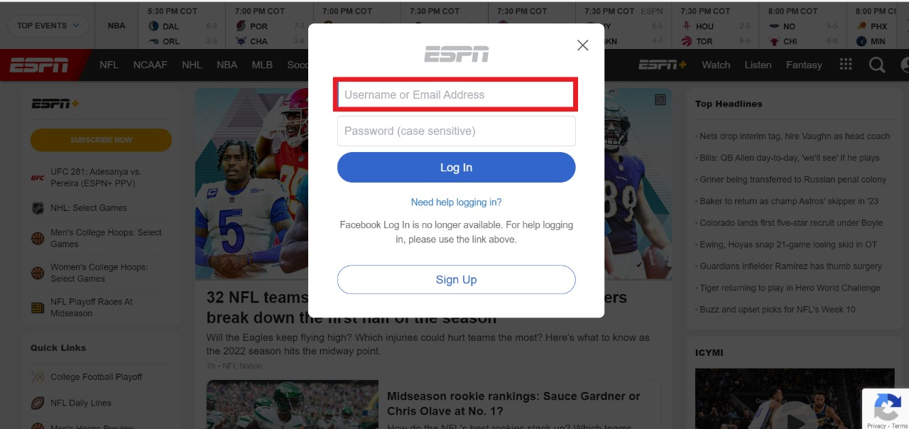

**Main Page (Login Page – Modal Window)**

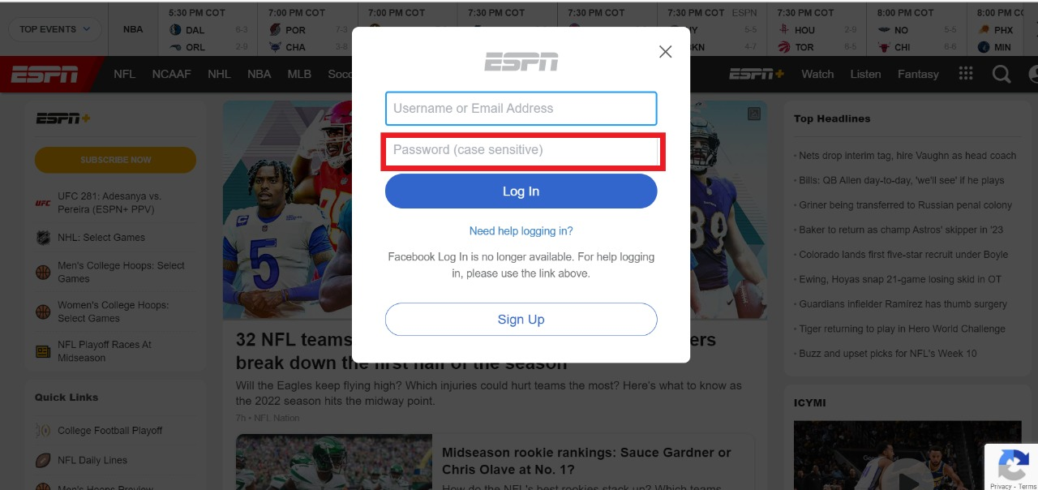

**Main Page (User Page – Modal Window)**

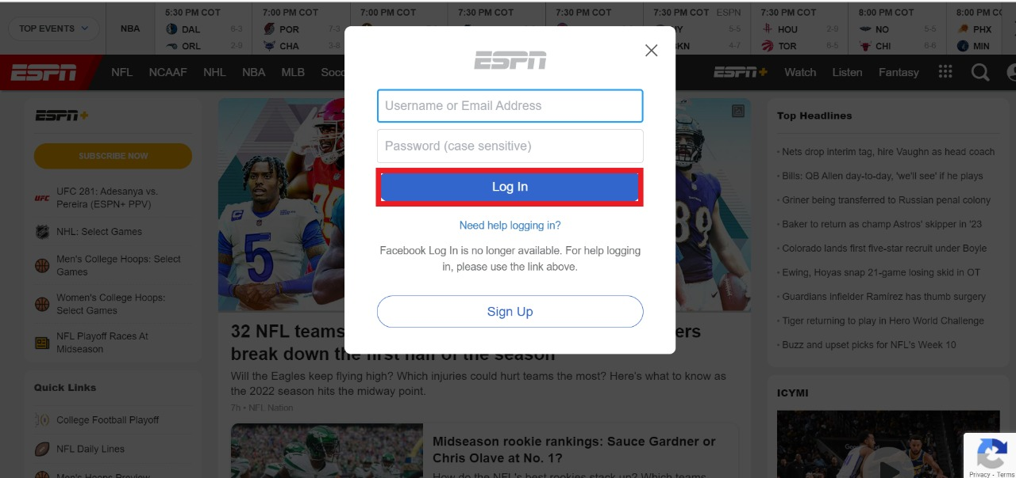

* **Logout Test:**

**Main Page**

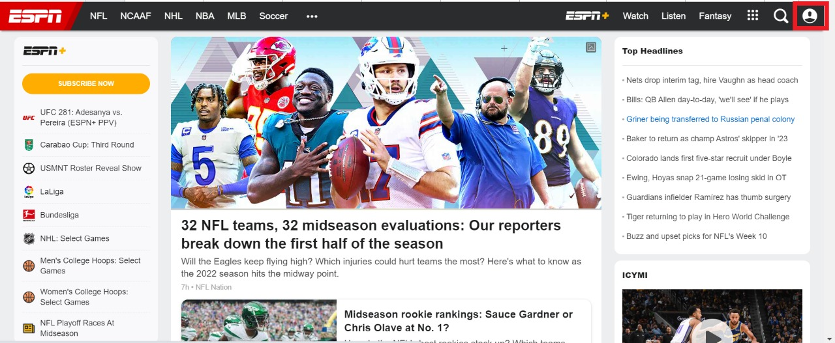

**Main Page (User Page – Modal Window)**

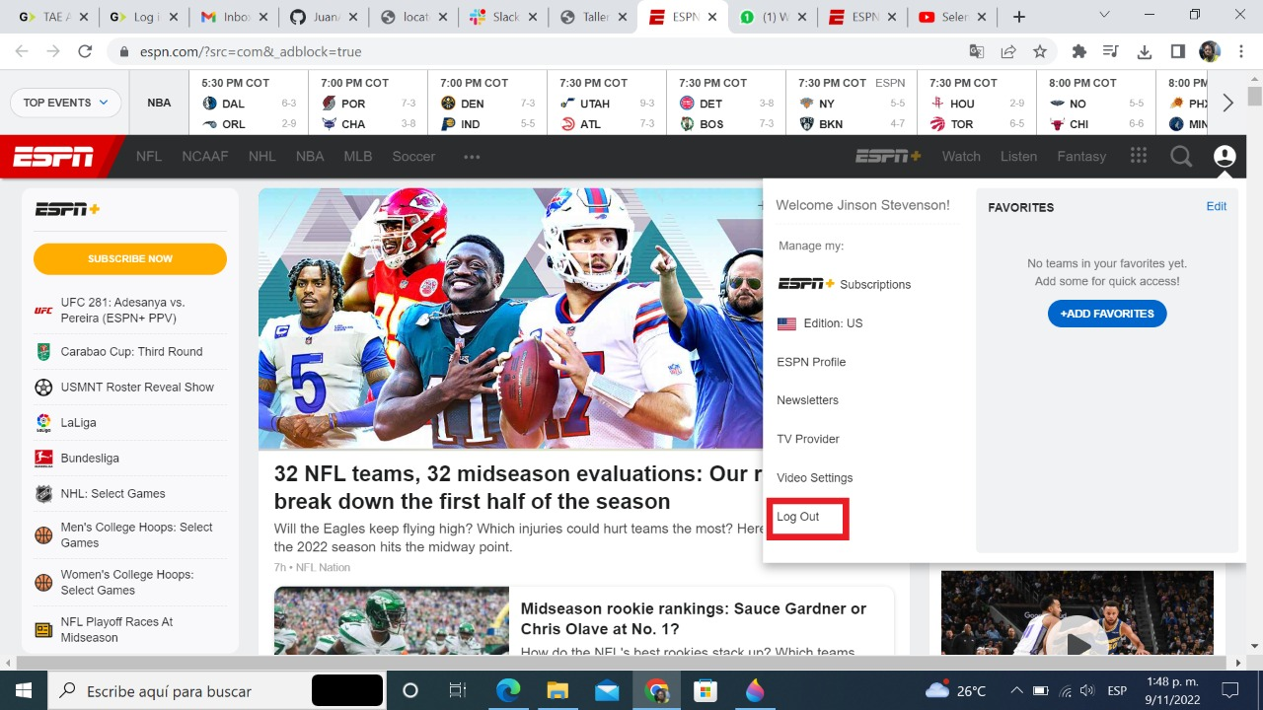

* **Deactivation test:**

**Main Page**



**Main Page (User Page)**

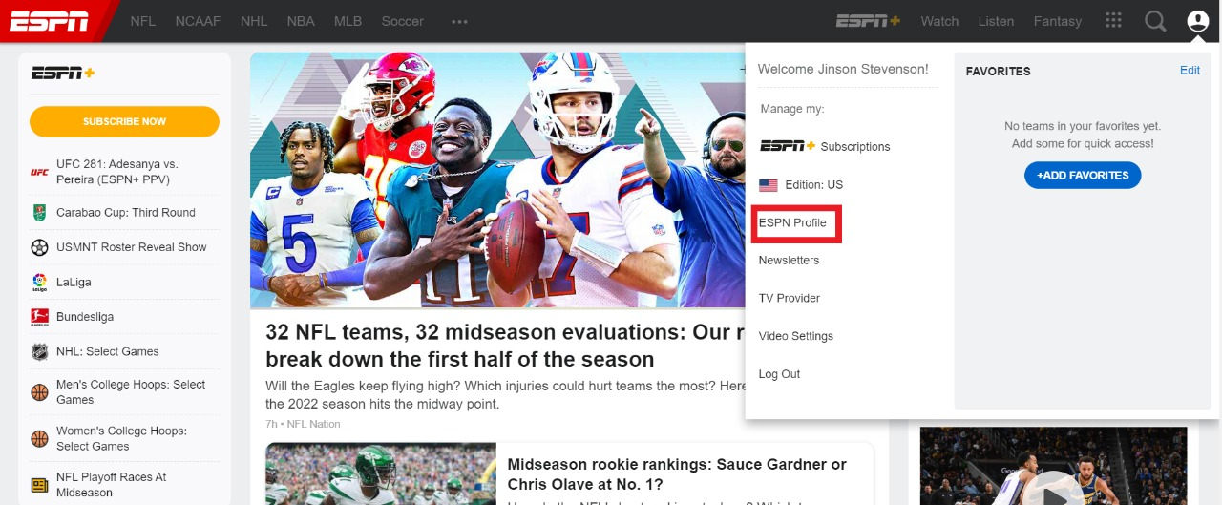

**Main Page (Profile Page – Modal Window)**

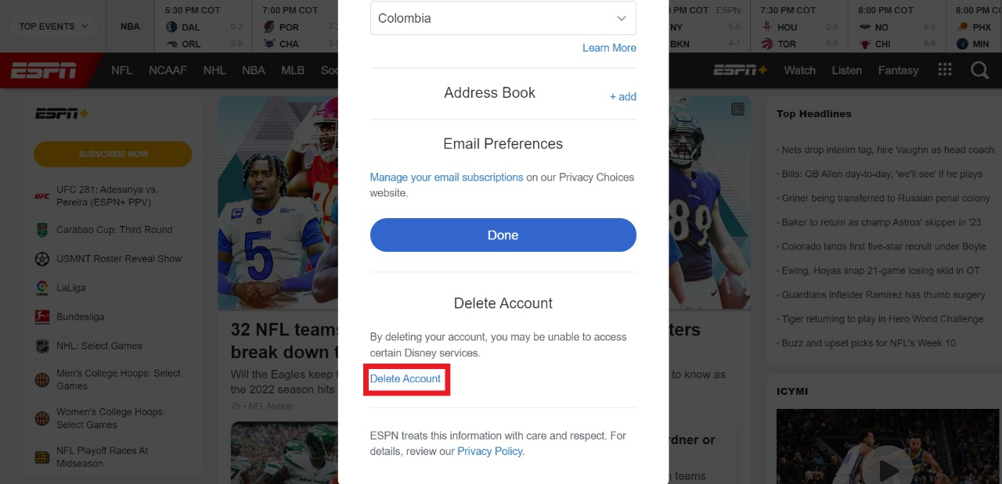

**Main Page (Modal Window)**

